**Bug ID: 1**

**Summary**: Contacts form – Submit button has to be disabled until all the input fields are filled

**Status:** New **Priority**: Low  
**Severity**: Minor  
**Assignee**: John Doe  
**Reporter**: Jane Doe  
**Env:** Production  
**Build version:** 1.0.0  
**Target version:** 1.0.1  
**Sprint:** 123  
**Linked story:** Story ID  
**Linked test case:** Test case ID  
**Bug type:** GUI  
**Phase:** UAT  
**Creation date:** 21/02/2021

**Description:**

**URL**: <https://www.veloceapps.com/contacts>

**Steps to reproduce**:

1. Open the URL provided
2. Leave All of the Form fields blank
3. Check ‘Submit’ button state

**Expected result:**

‘Submit’ button is disabled until all the necessary fields are filled.

**Actual result**:

‘Submit’ button is enabled although all the necessary fields are empty.

**Evidence:**

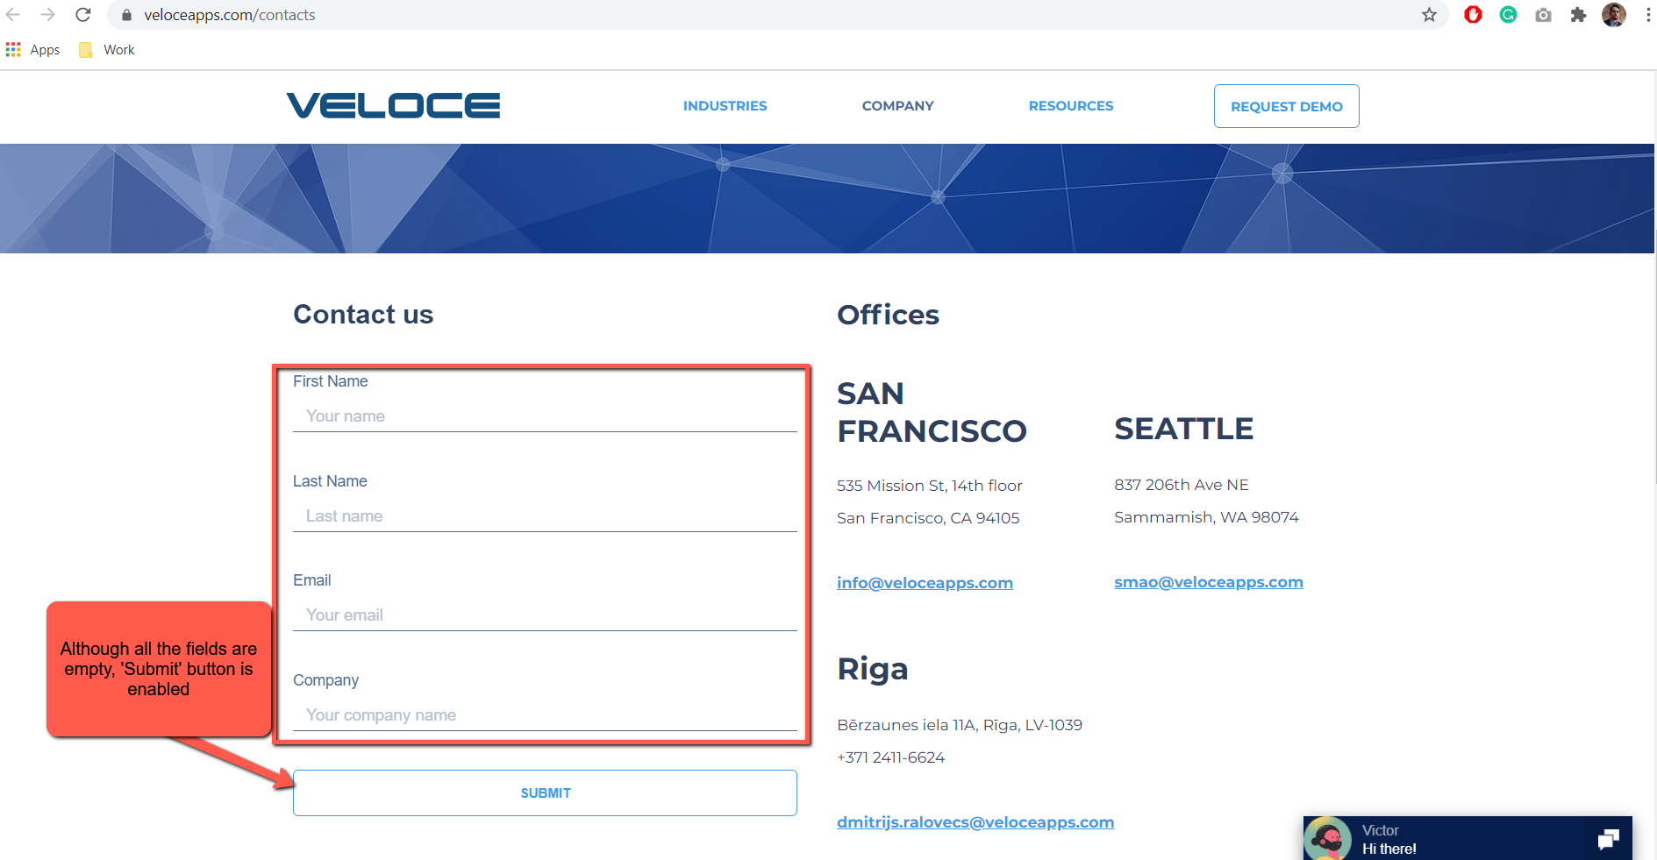

**Bug ID: 2**

**Summary**: Contacts form – Correct form submission results in 404 page

**Status:** New **Priority**: High  
**Severity**: Major  
**Assignee**: John Doe  
**Reporter**: Jane Doe  
**Env:** Production  
**Build version:** 1.0.0  
**Target version:** 1.0.1  
**Sprint:** 123  
**Linked story:** Story ID  
**Linked test case:** Test case ID  
**Bug type:** GUI  
**Phase:** UAT  
**Creation date:** 21/02/2021

**Description:**

**URL**: <https://www.veloceapps.com/contacts>

**Steps to reproduce**:

1. Open the URL provided
2. Fill all the Form fields with appropriate values
3. Click ‘Submit’ button
4. Fill all the second Form fields with appropriate values
5. Click ‘Submit’ button

**Expected result:**

‘Success’ message appears on the screen

**Actual result**:

‘404’ failure message appears on the screen

**Evidence:**

